Rapid changes to environmental conditions such as climate and landscape have become the normal conditions under which contemporary species must survive and reproduce. Therefore, rapid microevolutionary changes may be critical to the survival of species in an anthropogenic world. Rates of morphological adaptation of vertebrates, once thought to be incommensurate with ecological time scales, transpire quickly in some species under novel ecosystem pressures (Palkovacs et al. 2011). The majority of human-induced microevolutionary changes observed in animals, especially morphological changes, have been in aquatic systems, with fewer studies on birds and game animals, and almost none on non-game mammals. Surprisingly, few studies have examined morphological changes due to landscape change (Palkovacs et al. 2011). Intensive agriculture provides a natural experiment of rapid simplification of landscape structure and food types, and thereby communities of vertebrates. This rapid change provides an opportunity to test for morphological adaptations on an ecological time scale due to anthropogenic landscape modification.

*Peromyscus maniculatus bairdii* are an example of a species that has experienced drastic shifts in their environmental conditions over a short time period. *P.m. bairdii* are the prairie form of the common deer mouse, and are constrained to herbaceous landscapes throughout the Midwestern USA. Humans have modified 87% of this herbaceous landscape, mostly to agriculture (Samson et al. 2004). Following this conversion, *P.m. bairdii* have become the most common resident vertebrates of corn-soybean rotations (this study). This rapid conversion of prairie to row crops generated a novel biome in less than 200 years. In addition, this biome has been expanding longitudinally throughout the 200 years of conversion, which creates a natural laboratory for the examination of short-term and long-term effects (NASS and Wright and Wemberly 2013).

Part of the explanation for the success of *P.m. bairdii* in this new system may be the species’ tolerance of a novel diet of native and non-native insects and non-native weed and crop seeds (Whitaker 1966). While the non-native insects and weed seeds may be analogous to native species, corn and soybean are completely novel food items introduced by humans. In addition, the large quantity of this high quality waste grain makes it the most important winter source of calories in agricultural fields (Foster et al. 2010 and unpublished data). This food source is two orders of magnitude larger than common forb seeds (corn: 0.3g; velvetleaf: 0.001g), and this size difference may be a significant natural selection pressure on maxilla morphology.

In fact, we have found that the mice strongly prefer waste grain (corn and soybean) relative to any other seed type we tested (unpublished data). In order for the mice to process the relatively large but nutritious seeds, they may benefit from a new mandible morphology specialized for the task. Myers et al. (1996) have shown that deer mouse mandible morphology is only slightly plastic in its response to food hardness. We also know that gape and bite force are related, and that the morphology of the skull can be an important factor in the relationship of these two parameters (~~Davis et al. 2010, Williams et al. 2009~~). Due to this relationship, we expect that mandible morphology may be strongly correlated to feeding efficiency in the species.

Rodent morphological evolution studies are numerous (Boell and Tautz 2011, Hoekstra et al. 2006, Mullen and Hoekstra 2008, Pergams and Lacy 2008). For example, a closely related species *Peromyscus polionotus* has been a key example in evolution of coat color (Mullen and Hoekstra 2008). Researchers have found that strong selection by visual predators have likely led to coat color variations of subspecies. This approach has detected a top-down form of natural selection, with predation acting as a force of evolutionary change. Fewer studies have examined evolutionary changes of natural *Peromyscus sp.* populations due to bottom-up regulation from changes in food sources (but see Goheen et al. 2003). Goheen et al. (2003) did find morphological variation between locations for squirrels that had recently experienced a range expansion, and suggested cranial morphology changes could be associated with feeding efficiency on novel food items.

Given previous findings that food types can result in significant microevolutionary patterns (Philips and Shine 2004), *P.m. bairdii* could be an example of such contemporary evolution (*sensu* Stockwell et al. 2003). In order to determine the role of human-modified landscapes in this species’ evolution, we evaluate 1) the overall shape change in this species, 2) location-specific changes in morphology, to evaluate localized evolution due to agricultural intensification, and 3) the variation among locations, to determine if the homogenization of the region has led to reduced variation in the species.

**Methods**

*Digitization*

In order to test our hypotheses, we compared skull morphology of historic (1870-1910) to contemporary specimens of *Peromyscus maniculatus bairdii*. We created a collection of historic specimens, starting with a search of the online database gbif.org for museum collections of *P. m. bairdii* prior to 1910. In order to generate direct comparisons of historic and contemporary species, we narrowed the possible specimens based on the concentration of historical specimens, and limited possible locations to the Midwestern United States. Our research led us to locate and use specimens from northeastern Illinois; Iowa; northeastern and Manhatten, Kansas regions; southwestern Minnnesota; and northeastern North Dakota (Figure 1 and Table 1). We had specimens shipped from the National Museum of Natural History, and we visited the Bell Museum of Natural History (Chicago), University of Kansas Museum of Natural History, and University of Iowa Museum of Natural History. The vertebrate collection from the Museum of Natural History at Harvard was unavailable during our sampling period, due to renovations.

Based on our historic specimens, we were able to identify six concentrations of specimens that would allow for direct comparison to contemporary specimens. We collected contemporary specimens from each of the locations identified from this process. Mice were snap trapped, using Museum Specials within corn and soybean fields at each location. We collected specimens from six locations: Ames, IA; Ottawa, KS; Manhattan, KS, Emerado ND; Waseca, MN; and Shabbona, IL (Fig. 1). At each location, I attempted to collect 40 adult *P. m. bairdii*. We set traps for 1-3 nights between July and September 2012 in Iowa, Kansas, North Dakota and Minnesota. We set traps for 1-3 nights in July 2013 again in Minnesota and in Illinois. Specimens were put on ice and transported, below freezing, back to Iowa State University for processing. We removed skulls and placed them in a dermestid beetle colony until clean.

In order to determine the changes in shape of *P. m. bairdii* jaws, we collected data from upper and lower jaw structures associated with masticatory muscle attachments. To this end, I photographed skulls and mandibles separately for all specimens (excepting a small number of historic specimens that could not be disconnected). I used a common setup of a digital camera with a macro lens, set at approximately 0.5m from the specimen. I used a Canon EOS XT with a 8.0 MP sensor with a 100mm macro lens (EF = 1:2.8). After I had collected all pictures, I digitized maxilla-zygomatic plate and mandible landmarks for all specimens. Landmarks followed McPhee (2004) and Myers et al (1996), but modified for this species and question (figure 2). We digitized 9 landmarks and 7 semilandmarks on the maxilla-zygomatic plate, and 10 landmarks and 7 semilandmarks on the mandible. I digitized all specimens in tpsDig2 (vers. 2.17). We re-photographed 25% of the specimens to test for errors associated with order of photography. We found no evidence that specimens from the original documentation and the new test were any different (MS = 0.00247, p = 0.22). We re-digitized 10% of specimens and found a significant effect of extensive practice on digitization of maxillae, but not mandibles. Therefore, I digitized all specimen maxillae again in order to remove bias.

*Statistical Methods*

I conducted modern geometric morphometric analyses using *geomorph* (Adams and Otarola-Castillo, vers. 1.1-3) in R (vers. 3.0.2). This analysis uses a generalized Procrustes analysis (GPA: Gower 1975, Rohlf and Slice 1990). The process removes spatial artifacts of rotation and position of digitized specimens, leaving only metrics of shape (Zelditch 2004). Semilandmarks are slid along a 2D curve (see Bookstein 1991:376-382, 1997 for algorithm details) In this process, the centroid size (Csize) of each specimen is extracted, based on all of the landmarks. Based on these sizes, it can be determined if specimens experience allometric growth, or a change in shape correlated with growth in size. A common allometric component (CAC), which is a standardized measure of shape of a single specimen relative to the mean shape of all specimens, can also be calculated (Mitteroecker et al. 2004). When CAC is regressed on Csize, it can be determined if there is a significant trend in shape change with size.

When size and rotation have been removed, the landmarks of specimens are aligned to minimize differences across all landmarks. These values are used for the remaining analyses. The x,y coordinates of specimens can be compared as matrices of coordinates by location. In order to determine if significant differences exist between groups, we modeled the effects of year, location and the interaction on the shape of structures. This analysis produces Procrustes distances, and the sum of squares is evaluated against a Procrustes ANOVA, which is analogous to a permutational MANOVA (Goodall 1991, Anderson 2001). Thin plate spline deformation grids qualitatively describe changes in shape between historic and contemporary specimens. Non-parallel lines in a deformation grid indicate a change in shape. Trajectories of changes can also be calculated from the gpa-generated values. Specifically, the distance and direction of a trajectory are calculated in 2D space of PC axis 1 and 2. This is calculated from the reference (historic) to the target (contemporary) average specimen at each location. These trajectories are then evaluated against one another to determine significant differences in size or direction of change. (see Collyer and Adams 2007; Adams and Collyer 2007; Adams and Collyer 2009).

**Results**

We analyzed 150 historical and 160 contemporary specimens. The average shape had no outliers, and all specimens were included in the evaluation (Figure 1). We found significant allometry for mandibles and maxillae across all specimens (maxillae: MSE = 0.02, F1,305 = 72.43, p < 0.001; mandibles: MSE = 0.011, F1,305 = 62.61, p < 0.001). In addition to size, year is a significant predictor of the intercepts after accounting for location (maxillae: MSE = 0.001, F1,305 = 3.96, p = 0.048; mandibles: MSE = 0.007, F1,305 = 42.25, p < 0.001). Maxillae from 1900 and 2012 do not form distinct subgroups, while mandibles from the two time periods are clearly separated by the mean common allometric component (CAC) score, regardless of centroid size (Csize). (Figure X). Allometric slopes (interactions of year and size) of contemporary specimens were shallower than historic specimens (maxillae: MSE = 0.003, 0.085 vs. 0.188, F1,305 = 10.48, p = 0.001; mandibles: 0.101 vs. 0.134, MSE = 0.0004, F1,305 = 2.14, p = 0.14), with a significant effect of year on slope for maxillae, but not for mandibles. Mandibles, in contrast, were consistently correlated with a different shape within time, regardless of size (Figure 3 and 4). Contemporary specimens had significantly higher y-intercepts for both structures (maxillae: -0.23 vs. -0.50, F1,305 = 3.96, p = 0.048; mandibles: -0.28 vs. -0.39, F1,305 = 42.25, p < 0.001) (Figure 4), supporting different allometric growth patterns.

The average size of mandibles increased from 17.56 (0.89, 1SD) to 17.74 (0.87) (Figure X). Maxilla size also increased from 14.73 (0.92) to 15.03 (0.89). Year and location were both significant predictors of Csize for mandibles and maxillae, but there were no significant interactions (maxilla year: MSE = 7.42, F1,299 = 10.15, p = 0.002; maxilla location: MSE = 5.63, F5,299 = 7.70, p < 0.001 and mandible year: MSE = 2.825, F1,299 = 4.10, p = 0.04; mandible location: MSE = 5.84, F5,299 = 8.48, p <0.001; interaction effects: p = 0.13 and 0.09) (Figure 5).

Mouse maxilla and mandible morphology is significantly different between years across the Midwestern US and within each location (maxillae: location: MSE = 0.009, p = 0.01; year: MSE 0.011, p = 0.01; interaction: MSE = 0.009, p = 0.01 and mandibles: location: MSE = 0.004, p = 0.01; year: MSE = 0.027, p = 0.01). Interaction effects for both structures were also significant (maxillae: MSE = 0.009, p = 0.01; mandibles: MSE = 0.005, p = 0.01). Trajectories of evolutionary change show that maxillae have experienced little directional change along the two major PC axes (Figure 6). In contrast, mandible morphology has clearly experienced a directional change across the Midwestern US, as contemporary specimens are to the left of the average value on PC I, while historic specimens are to the right of this average value. In contrast, mandibles have more occurrences of significantly different trajectory orientations by location than do maxillae (Table 3). Maxillae actually have more instances of significantly different sizes than do mandibles, though. Only Ottawa, KS mandibles had a significantly larger trajectory of change than other locations.

In summary, mandibles tended to broaden at the (Figure 7).

**Conclusions**

We found significant differences that could be explained by both location and time. The variation in trapping time and year ameliorate the effects of diet on plasticity, as PEMA are omnivores, and utilize seeds and insects throughout the spring and summer months. The different values for mandibles, even at small sizes indicate that even young mice, which are unlikely to have experienced waste grain, have different morphologies than their ancestors. Allometry also supports a truncation of plasticity, as slopes of contemporary specimens are smaller than ancestral specimens, indicating less developmental morphology change in the species than was present historically.

Myers: significant changes in skull with hard diet – smaller lateral centroid size, broader zygomatic plate, movement in posterior position of incisor insertion, and foramen that I excluded – only the last was not also significantly influenced by family membership

Volkman(thesis): significant changes in mandible with hard diet – significantly larger csize liquid to pellet-fed (~1.5%), taller (~6%/3%powder), condyle wider than liquid (7%) and powder (1%), some effects on length, but not compelling (max 1.5%); diet explains 7.2% and family explains 41.2%, without correction by family, ~50% of pellet-fed mice are misclassified by diet

Holbrook(Journal of Mammalogy 1982): grassland vs. woodland maniculatus have different mandible morphologies

McPhee 2004 JMamm: 35 generations of relaxed selection resulted in P. polionotus distinct from wild-caught or founder mice

Morphological changes are much larger versions of the changes seen in lab studies with increased food hardness, and changes match predictions of muscle attachment and bite force.

Rapid morphological change as adaptation to human modification

Omnivore who may becoming more specialized on hard diet, as it may be more limiting in the winter (polar bears)

Adaptation to seeds supported by high intensity corn populations having larger changes in morphology, relative to low-intensity areas, but still planted to grain.

Species are adapting to rapid human change. This study supports this sort of rapid change. It also suggests that the options and degree of change for mice may be “running out”. This species is a prime example of an ecosystem service provider, and it also has adapted, despite omnivory and generalization. In order to protect valuable services, we should take careful note of morphological changes associated with the services provided (in this case, eating). Future changes or “ceilings” may ultimately limit the utility of the species, and if the population were any smaller or less diverse, it may not have worked. Generalists often thrive where specialists struggle, this adds one more piece of evidence to explain this resiliency. We should take careful note of what it takes for success, and maybe identify species that have the most potential, as well as those that may be running out of evolutionary room.

**References**

Adams, D. C., and M. L. Collyer. 2007. The analysis of character divergence along environmental gradients and other covariates. Evolution 61:510-515.

Adams, D. C., and M. L. Collyer. 2009. A general framework for the analysis of phenotypic trajectories in evolutionary studies. Evolution 63:1143-1154.

Bookstein, F. J. 1991 Morphometric Tools for Landmark Data: Geometry and Biology. Cambridge University Press, New York.

Bookstein, F. J. 1997 Landmark Methods for Forms without Landmarks: Morphometrics of Group Differences in Outline Shape. Medical Image Analysis 1(3):225-243.

Collyer, M. L., and D. C. Adams. 2007. Analysis of two-state multivariate phenotypic change in ecological studies. Ecology 88:683-692.

Mitteroecker, P., P. Gunz, M. Bernhard, K. Schaefer, and F. L. Bookstein. 2004. Comparison of cranial ontogenetic trajectories among great apes and humans. J. Hum. Evol. 46:679-698.

Anderson MJ. 2001. A new method for non-parametric multivariate analysis of variance. Austral Ecology 26: 32'46.

Goodall, C. R. 1991. Procrustes methods in the statistical analysis of shape. Journal of the Royal Statistical Society B 53:285-339.

Drache, Hiram M. “The Impact of John Deere’s Plow.” Illinois History Teacher. 8.1 (2001): 2-

13. Web. 24 Oct. 2011.

Gower, J. C. 1975. Generalized Procrustes analysis. Psychometrika 40:33-51.

Grant and Grant 2002. Unpredictable Evolution in a 30-Year Study of Darwin's Finches

Rohlf, F. J., and D. E. Slice. 1990. Extensions of the Procrustes method for the optimal superimposition of landmarks. Syst. Zool. 39:40-59.

16. Merilä J, Kruuk LEB, Sheldon BC (2001) Cryptic evolution in a wild bird population.

Nature 412:76–79.

17. Wilson AJ, et al. (2007) Quantitative genetics of growth and cryptic evolution of body

size in an island population. Evol Ecol 21:337–356.

18. Kruuk EB, et al. (2002) Antler size in red deer: Heritability and selection but no

evolution. Evolution 56:1683–1695.

19. Coltman DW, et al. (2003) Undesirable evolutionary consequences of trophy hunting.

Nature 426:655–658.

20. Réale D, McAdam AG, Boutin S, Berteaux D (2003) Genetic and plastic responses of

a northern mammal to climate change. Proc Biol Sci 270:591–596.

21. Garant D, Kruuk LEB, Wilkin TA, McCleery RH, Sheldon BC (2005) Evolution driven by

differential dispersal within a wild bird population. Nature 433:60–65.

22. Teplitsky C, Mills JA, Alho JS, Yarrall JW, Merilä J (2008) Bergmann’s rule and climate

change revisited: Disentangling environmental and genetic responses in a wild bird

population. Proc Natl Acad Sci USA 105:13492–13496.

23. Hadfield JD, Wilson AJ, Garant D, Sheldon BC, Kruuk LEB (2010) The misuse of BLUP in

ecology and evolution. Am Nat 175:116–125.

Table 1. Summary of specimen collection sites in 1900 and 2012 and intensity of row-crop agriculture in 2012. Location is an estimate from historical records (with predominate location in parentheses) and using online mapping software to estimate the location of each field sampled. 1900 is the average year when all historical specimens were collected. 2012 specimens are from the summer of 2012 and 2013. Percent corn in 2012 is based on NASS ( ) statistical database. The acres of land planted to corn were divided by the recorded size of each county in which sampling occurred.

|  |  |  |  |
| --- | --- | --- | --- |
|  | Location | | % Corn & Soybean 2012 |
|  | 1900 | 2012 |  | |
| Illinois (N=40) | Cook and Lake County | 41.83913,-88.865365 | 81 | |
| Iowa (N=53) | Knoxville and Central Iowa | 41.990805, -93.685187 | 76 | |
| Minnesota (N=41) | Fort Snelling | 44.070972,-93.525711 | 75 | |
| North Dakota (N=53) | Northeast North Dakota | 47.953432,-97.434925 | 33 | |
| Ottawa, KS (N=75) | Lawrence | 38.537739,-95.245275 | 21 | |
| Manhattan, KS (N=48) | Onaga | 39.213044,-96.595392 | 14 | |

Table 2. Allometric values for maxilla (top) and mandibles (bottom). Average CAC and Csize are means of all specimens from that location in that sampling period. 1900 is the average year when all historical specimens were collected. 2012 specimens are from the summer of 2012 and 2013. CAC is common allometric component, and represents a standardized value of shape for each specimen. Csize is centroid size, and is a size measure based on the landmarks used for the study. REPLACE with values from R ddply

|  |  |  |  |  |
| --- | --- | --- | --- | --- |
|  | Average CAC | | Average Csize | |
|  | 1900 | 2012 | 1900 | 2012 |
| North Dakota (N=53) | 0.0005 | 0.00005 | 2.69 | 2.72 |
| Iowa (N=53) | 0.011 | -0.011 | 2.72 | 2.69 |
| Manhattan, KS (N=48) | 0.0046 | -0.004 | 2.71 | 2.75 |
| Illinois (N=40) | -0.006 | 0.005 | 2.68 | 2.72 |
| Ottawa, KS (N=75) | -0.013 | 0.005 | 2.66 | 2.69 |
| Minnesota (N=41) | 0.000027 | -0.002 | 2.65 | 2.68 |
|  | Average CAC | | Average Csize | |
|  | 1900 | 2012 | 1900 | 2012 |
| North Dakota (N=53) | -0.009 | 0.010 | 2.856 | 2.89 |
| Iowa (N=53) | -0.0008 | 0.0005 | 2.89 | 2.88 |
| Manhattan, KS (N=48) | -0.003 | 0.006 | 2.89 | 2.92 |
| Illinois (N=40) | -0.005 | 0.004 | 2.86 | 2.86 |
| Ottawa, KS (N=75) | -0.011 | 0.007 | 2.84 | 2.86 |
| Minnesota (N=41) | -0.007 | 0.004 | 2.84 | 2.85 |

Table 3. Significant differences in evolutionary trajectories by location. Only significant (or nearly significant) p-values are listed in the table below. A significant p-value indicates that the trajectories of the two location are significantly different in size or direction of change. Size of change represents the magnitude of difference between historic and contemporary specimens, while the orientation represents the direction of change in PC space, based on the first two PC axes. All sample sizes are the same as in previous tables and figures, based on the following: EMND – Emerado, North Dakota (contemporary) and northeastern ND (historic); IOWA – Ames, IA (contemporary) and central IA (historic); MAKA – Manhatten, KS (both); NILL – Shabbona, IL (contemporary) and northeastern IL (historic); OTKA – Ottawa, KS (contemporary) and Lawrence and Fort Leavenworth (historic); WAMN – Waseca, MN (contemporary) and south-central MN (historic).

|  |  |  |  |  |  |  |  |  |  |  |  |  |  |
| --- | --- | --- | --- | --- | --- | --- | --- | --- | --- | --- | --- | --- | --- |
|  |  | Maxillae | | | | | | Mandibles | | | | | |
|  |  | EMND | IOWA | MAKA | NILL | OTKA | WAMN | EMND | IOWA | MAKA | NILL | OTKA | WAMN |
| Size | EMND |  | -  -  - | | | | |  |  |  |  |  |  |
| IOWA | 0.01 |  | -  -  - | | | | - |  |  |  |  |  |
| MAKA | 0.02 | - |  | - | | | - | - |  |  |  |  |
| NILL | - | 0.01 | 0.03 |  |  | | - | - | - |  |  |  |
| OTKA | 0.02 | 0.07 | - | 0.06 |  |  | 0.02 | 0.01 | 0.01 | 0.11 |  |  |
| WAMN | 0.04 | 0.05 | - | 0.06 | - |  | - | - | - | - | 0.06 |  |
| Orientation | EMND |  |  |  |  |  |  |  |  |  |  |  |  |
| IOWA | 0.02 |  |  |  |  |  | - |  |  |  |  |  |
| MAKA | 0.02 | 0.03 |  |  |  |  | 0.03 | - |  |  |  |  |
| NILL | - | - | - |  |  |  | 0.04 | 0.04 | 0.03 |  |  |  |
| OTKA | - | 0.03 | - | - |  |  | 0.02 | 0.01 | 0.01 | 0.07 |  |  |
| WAMN | - | - | - | - | 0.07 |  | 0.04 | - | 0.02 | - | - |  |

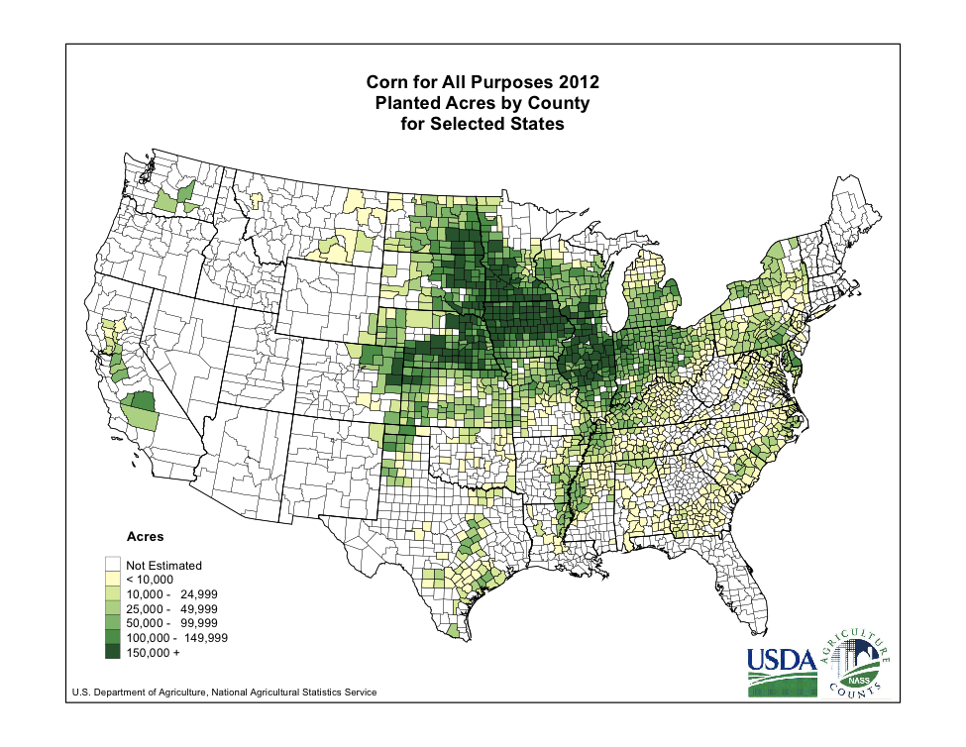

EMND

OTKA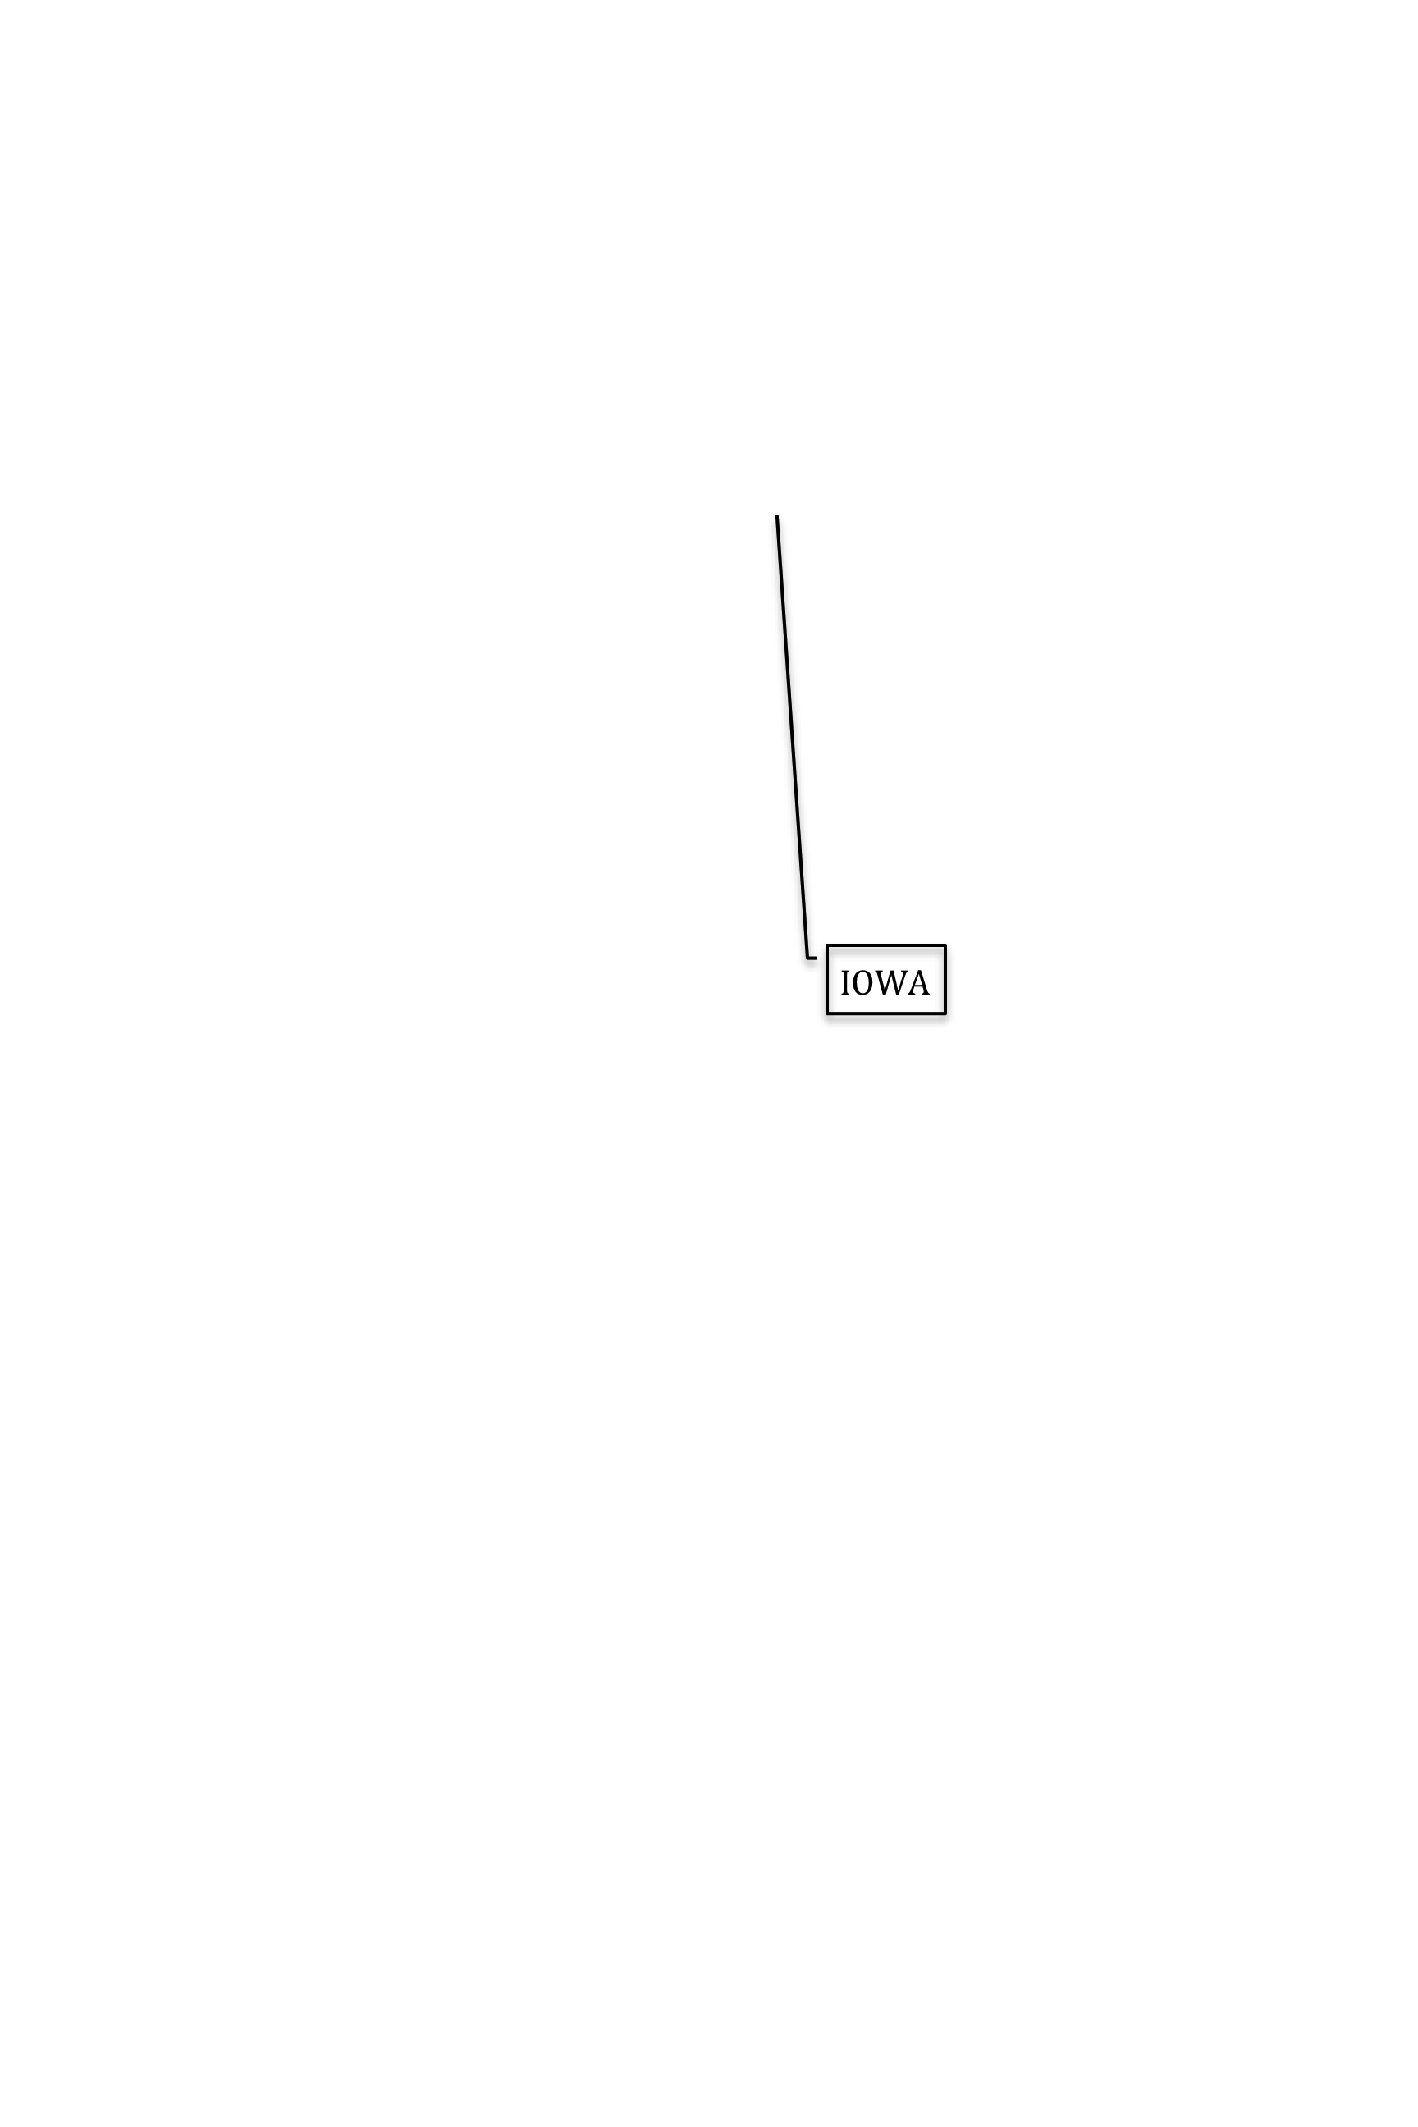

MAKA

IOWA

WAMN

NILL

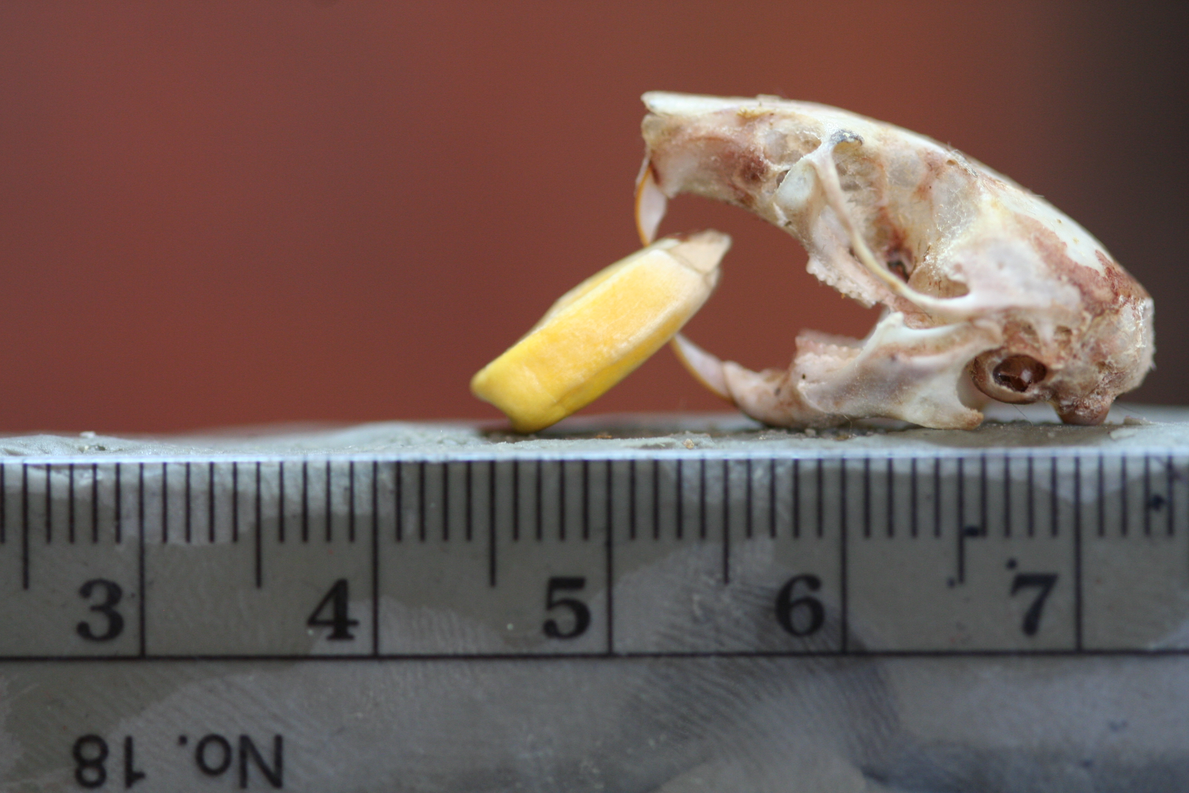

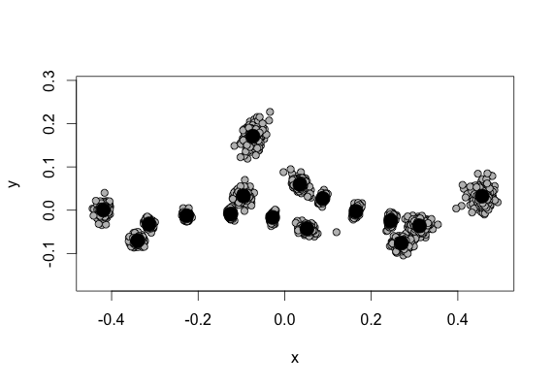

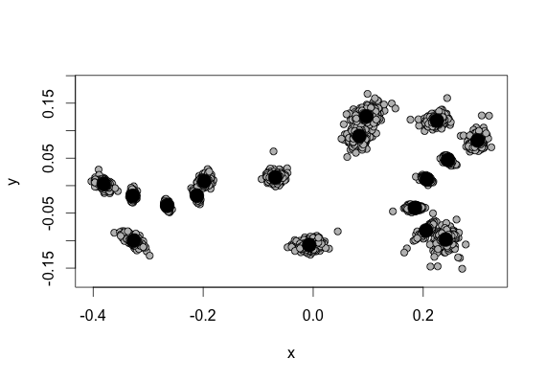

Figure 1. Landmarks and semilandmarks used for morphometric analysis. Landmarks follow …

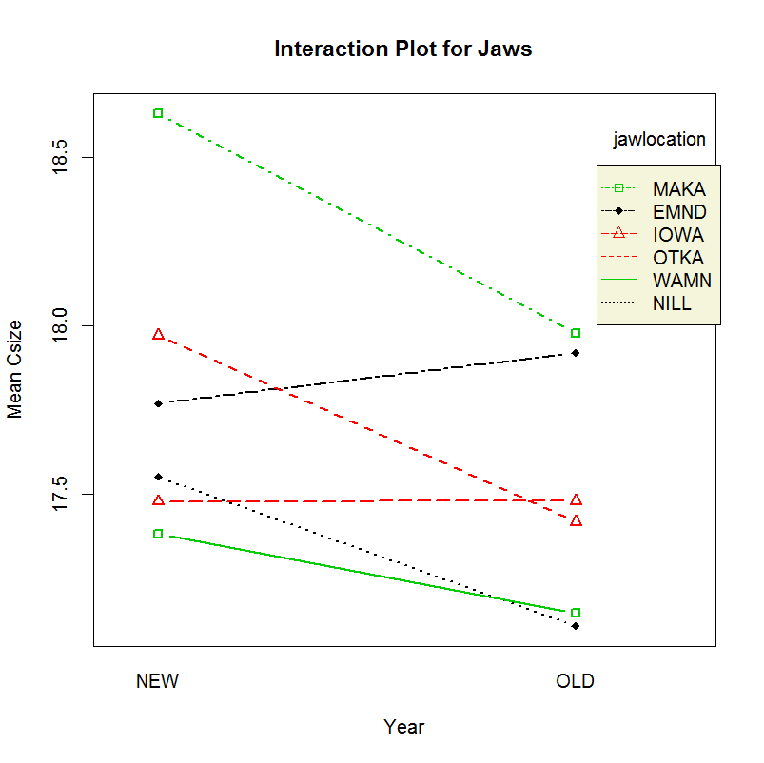



Figure 2. Size differences in mouse mandibles and maxillae. All data depict average (and on bottom the standard deviation of) centroid size, which is calculated using all landmarks included in the morphometric analysis. The top figures depict mandible and maxilla size differences by location and year. Site acronyms are as in table 3. Site-specific sample sizes are as follows: EMND(31/22;contemporary/historic), IOWA(28/25), MAKA(16/32), NILL(24/16), OTKA(35/40), WAMN(26/15). The bottom figures depict the average (+- 1SD) of centroid size by year. Significant differences are indicated by asterisks.



Figure 3. Allometry of maxillae and mandibles. Data are generated by plotting the relationship between centroid size and common allometric component. Black circles are all specimens (N=310) from museum collections and 2012-2013 trapping sessions. Thin plate spline deformation grids in corners represent maximum morphological change based on size change. Red squares are contemporary specimen average values by location. Blue diamonds are historic specimen average values by location.



 

Figure 4. Top: “Built-in” prediction line, using geomorph in R. Bottom: “Homemade” depiction of the same. In both cases, prediction lines represent a regression of shape values within a group – in this case, time. Allometry tests show significant effects of size and year on shape for both structures. Interaction of size:year is significant for maxillae, but not mandibles. Regression lines are historic maxillae: CAC = 0.1876*Csize - 0.5037; contemporary maxillae: CAC = 0.08492*Csize - 0.23; historic mandibles: CAC = 0.134*Csize – 0.3886; contemporary mandibles: CAC = 0.1005*Csize – 0.284.

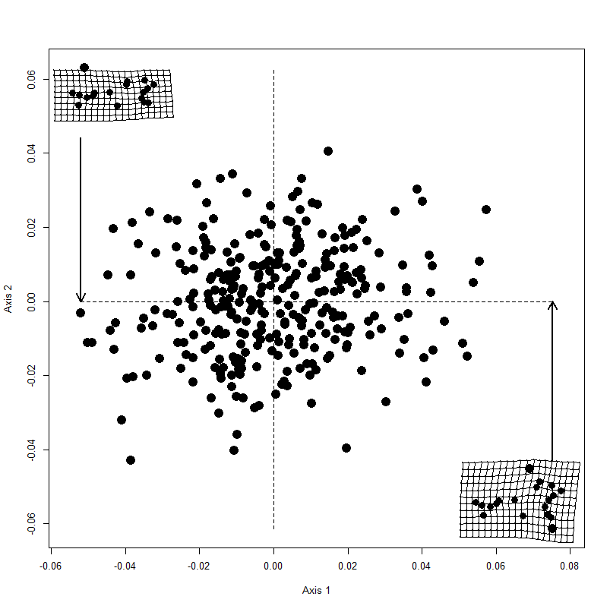

Figure 5. Tangent space for maxillae (top) and mandibles (bottom). PC axes I and II explain the maximum amount of variation in the data (maxillae: 27 and 13%, mandibles: 25 and 13%). The thin plate spline deformation grids in each corner represent the largest difference among all specimens, by indicating what each structure looks like at the high and low ends of PC axis I.

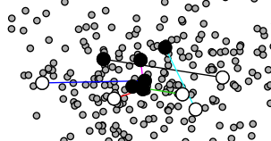

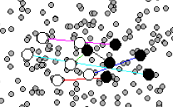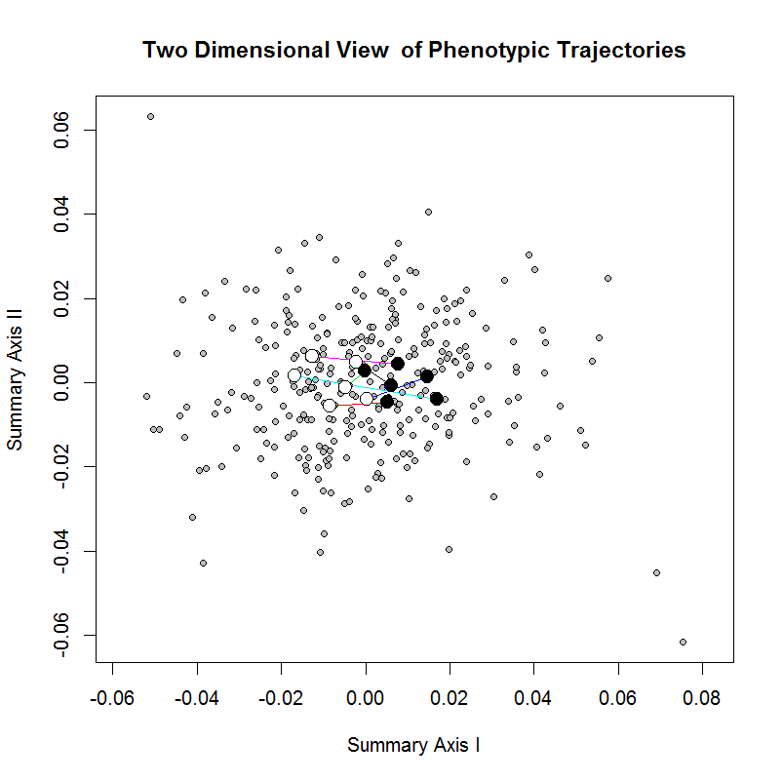

Figure 6. Trajectories of shape change in maxillae (top) and mandibles (bottom) by location. Circles are historic (black) and contemporary (white) location averages. Lines connect the historic and contemporary average specimen, and are color-coded by location (black = EMND, red = IOWA, green = MAKA, blue = NILL, cyan = OTKA, and magenta = WAMN). See Table 3 for significant differences among locations for trajectory size and orientation.

|  |  |  |
| --- | --- | --- |
| North Dakota |  |  |
| Iowa |  |  |
| Illinois |  |  |
| Manhatten, KS |  |  |
| Ottawa, KS |  |  |
| Minnesota |  |  |

Figure 7. Location-specific changes in maxillae and mandible shape. Thin plate spline deformation grids illustrate the changes in shape that have occurred in each location between approximately 1900 and 2012. These TPS grids are shown at 3x magnification to clarify changes. Parallel lines represent no change between objects, and all non-parallel lines represent a warping of the shape.